Enter-Exit System (BCG Shared Assets)

Supports all BCG vehicle controllers at the moment. Enables / disables character controllers, registers / deregisters vehicles, and observes all events.

First, you have to import “BCG Shared Assets” into your project in order to use enter / exit system. It will add necessary scripts and resources to use your FPS or TPS player for enter / exit vehicles. Package is located in “Addon Packages\For BCG Shared Assets (Enter-Exit)” folder. You can also import integration package from welcome window too. Tools BCG RCC Welcome Window Addons.

There will be two new scenes imported to the “Demo Scenes” folder. One for FPS, and the other one for TPS controllers. FPS and TPS controllers are using different cameras. Usually, camera of the FPS character is in the gameobject. But TPS characters have unattached and independent cameras, and they are not parented to the character. Therefore, BCG_EnterExitPlayer.cs script has two options for usement with FPS or TPS. If TPS is choosen, you must declare the TPS camera in the scene.

You can edit some settings from (Tools BCG Shared Assets Edit Settings).

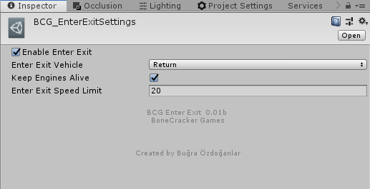

How The System Works (Simple)

All RCC vehicles have “BCG_EnterExitVehicle” component. And our FPS/TPS character has “BCG_EnterExitPlayer” component. BCG_SceneManager (Will be created automatically) will be observing all vehicles and your character in the scene. If vehicle has no driver, *canControl of the vehicle will be disabled, and not registered as player vehicle. If our character has entered any vehicle, BCG_SceneManager will register the target vehicle as player vehicle, enables the canControl of the vehicle. At that moment, our character will be parented to the vehicle and disabled entirely. Now, BCG_EnterExitVehicle has a **driver now. If player gets out from the vehicle, BCG_SceneManager will be activating character controller, and transport it to “Get Out Pos” of the vehicle. And lastly, deregister the vehicle and disable *canControl of the vehicle. Now, vehicle is not controllable, not a player vehicle.

* = canControl bool of the RCC_CarControllerV3. If it’s enabled, the vehicle is controllable.
** = driver variable of the BCG_EnterExitVehicle.

How To Make It Work

All you have to do is, add necessary scripts to the vehicles and to your player. Get out position of the vehicles are created automatically in script if you don’t select it in BCG_EnterExitCar. You can replace get out positions.

For FPS characters, it will depend on your camera of the FPS player. For TPS player, it depends on your actual TPS Player, not camera.

Character Controllers must have BCG_EnterExitPlayer
Vehicles must have BCG_EnterExitVehicle

_BCGEnterExitManager will be created automatically in your scene. _BCGEnterExitManager will be managing all the process.

How The System Works (Detailed)

Please read simple version first if you haven’t read. Let’s get it straigth with more detailed version;

- BCG_EnterExitVehicle – must be attached to all vehicles.
- BCG_EnterExitPlayer – must be attached to the character.
- BCG_EnterExitManager – will be created automatically.

All the system is based on events. BCG_EnterExitPlayer is firing an event when it’s spawned, destroyed, gets in a vehicle, or gets out of the vehicle. BCG_SceneManager will be listening to this event as well. So, manager knows your all of your character events. All events are explained below;

public delegate void onBCGPlayerSpawned(BCG_EnterExitPlayer player);
public delegate void onBCGPlayerDestroyed(BCG_EnterExitPlayer player);
public delegate void onBCGPlayerEnteredAVehicle(BCG_EnterExitPlayer player, BCG_EnterExitVehicle vehicle);
public delegate void onBCGPlayerExitedFromAVehicle(BCG_EnterExitPlayer player, BCG_EnterExitVehicle vehicle);

You can listen any events on the BCG_EnterExitPlayer or BCG_EnterExitVehicle. For example;

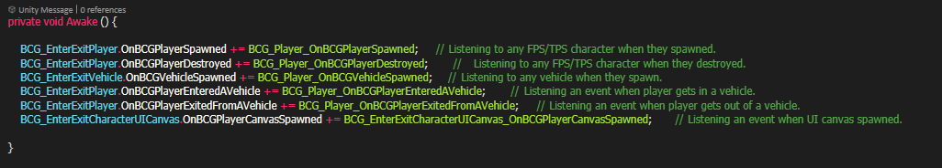

Nice color scheme, isn’t it? Anyways, BCG_EnterExitManager will use using GetIn() or GetOut() methods by listening these events. GetIn() method requires “targetVehicle”. GetOut() method doesn’t require any parameters.

When our character standing next to the any vehicle, get in text will be enabled by BCG_EnterExitPlayer. If player pushes the interaction button, OnBCGPlayerEnteredAVehicle event will be fired with targetVehicle data. As you well now, this event has been listening by BCG_SceneManager. So, BCG_SceneManager will be firing GetIn(targetVehicle) method to do the rest.

